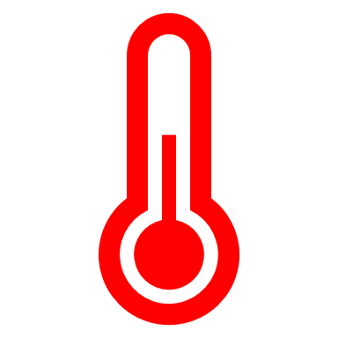
Procedure for Hot Water Testing during Supportive Living Site Visits

Preparation:
☐ Prior to conducting a compliance inspection, Program Advisors must ensure that they have all necessary equipment, including a digital thermometer and a cup or glass.
☐ If an excessive amount of hot water has been used just prior to the inspection (bathing/showering), the Program Advisors may choose to test the water at the end of the inspection.

Testing Method:
☐ Upon arrival to the residence or at the end of the inspection, when conduct hot water testing Program Advisors must allow water to run for 1 ½ to 2 minutes uninterrupted at the hottest setting (longer time if site has tankless water heater)
☐ Program Advisors may choose to test at different locations i.e. kitchen, bathroom/shower.
☐ Program Advisors will then fill a cup or glass with the hot water and test the temperature using a digital thermometer. The water should be allowed to continuously flow from the cup/glass while taking the temperature reading.
☐ The temperature of the water must not be hotter than 49 degrees Celsius.

Record Keeping:
☐ Service agencies must have and follow the method of temperature control, monitoring, and documentation to ensure that in each residence water from a faucet is not hotter than 49 degrees Celsius.
☐ The testing method and documentation of hot water temperature must be consistent with the service agency’s policies and procedures on temperature control, monitoring, and documentation as required by Regulation 299/10, Quality Assurance Measures.

Recommendations:
☐ For consistency, the Ministry recommends the service agency implements the same hot water testing method performed by the Program Advisor during a DS Compliance inspection.
☐ The Ministry recommends the service agency conducts daily checks of the water temperature to detect changes and anomalies in water temperature that can occur over time or because of faulty mixing valves.
Note: In multiple-unit apartment/high-rise building setting where agencies cannot control the water temperature or install mixing valves, agencies should have policies and procedures to prevent scalding where it cannot automatically control the maximum hot water temperature in a residence. For example, specific individual bathing, hygiene protocols outlining safeguards and how persons receiving service are supported to prevent scalding (e.g., steps outlined to keep persons safe) may be used to demonstrate compliance with this requirement (for example, having staff check the water temperature before a bath).

